Week 6 : HandsOn
React
ReactJS-HOL-1
Objective:
Create a new React Application with the name “myfirstreact”, Run the application to print “welcome to the first session of React” as heading of that page.
Steps:
1.Installing nodejs and npm
2.Install create-react-app
npm -g create-react-app
3. Create react application
npx -g create-react-app myfirstreact
4. Opening the folder in Visual Studio Code and replacing the App.js content:
import logo from './logo.svg';
import './App.css';
function App() {
return (
<div className='App'>
<h1>Welcome to the first session of React</h1>
</div>
);
}
export default App;

Output:

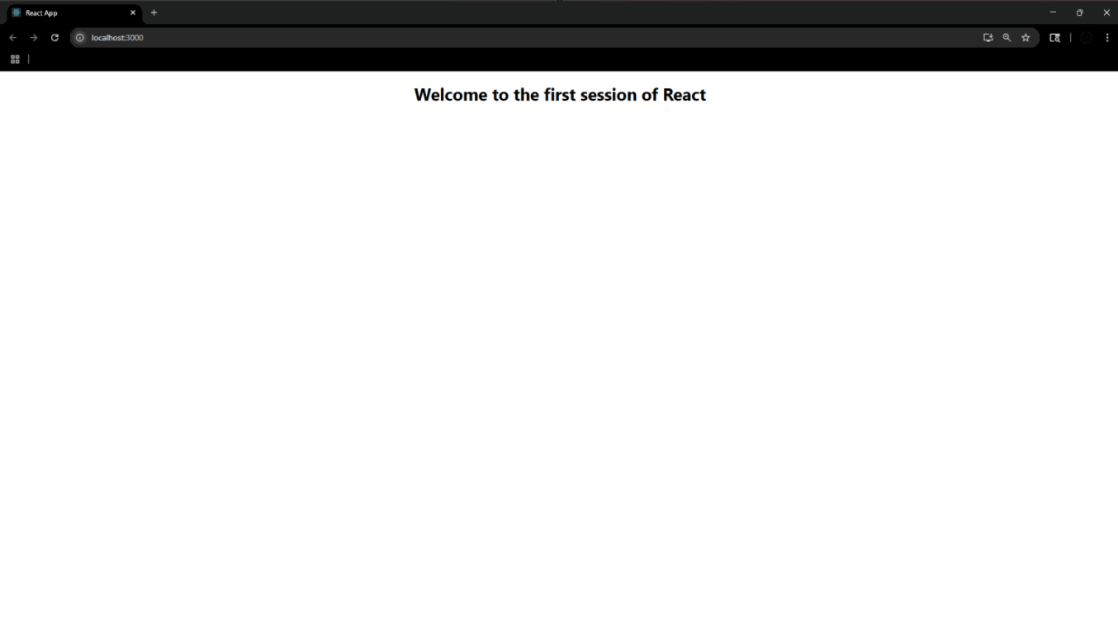

ReactJs-HOL-2
Steps:
1.Create project named StudentApp
npx create-react-app StudentApp
2. Creating new folders under Compenents:
- Home.js
- About.js
- Contact.js
Program:
Home.js
import React from 'react';
function Home() {
return (
<div>
<h2>Welcome to the Home page of Student Management Portal</h2>
</div>
);
}
export default Home;

About.js
import React from 'react';
function About() {
return (
<div>
<h2>Welcome to the About page of the Student Management Portal</h2>
</div>
);
}
export default About;

Contact.js
import React from 'react';
function Contact() {
return (
<div>
<h2>Welcome to the Contact page of the Student Management Portal</h2>
</div>
);
}
export default Contact;

3. Update App.js
import React from 'react';
import './App.css';
import Home from './Components/Home';
import About from './Components/About';
import Contact from './Components/Contact';
function App() {
return (
<div className="App">
<Home/>
<About/>
<Contact/>
</div>
);
}
export default App;
Output:
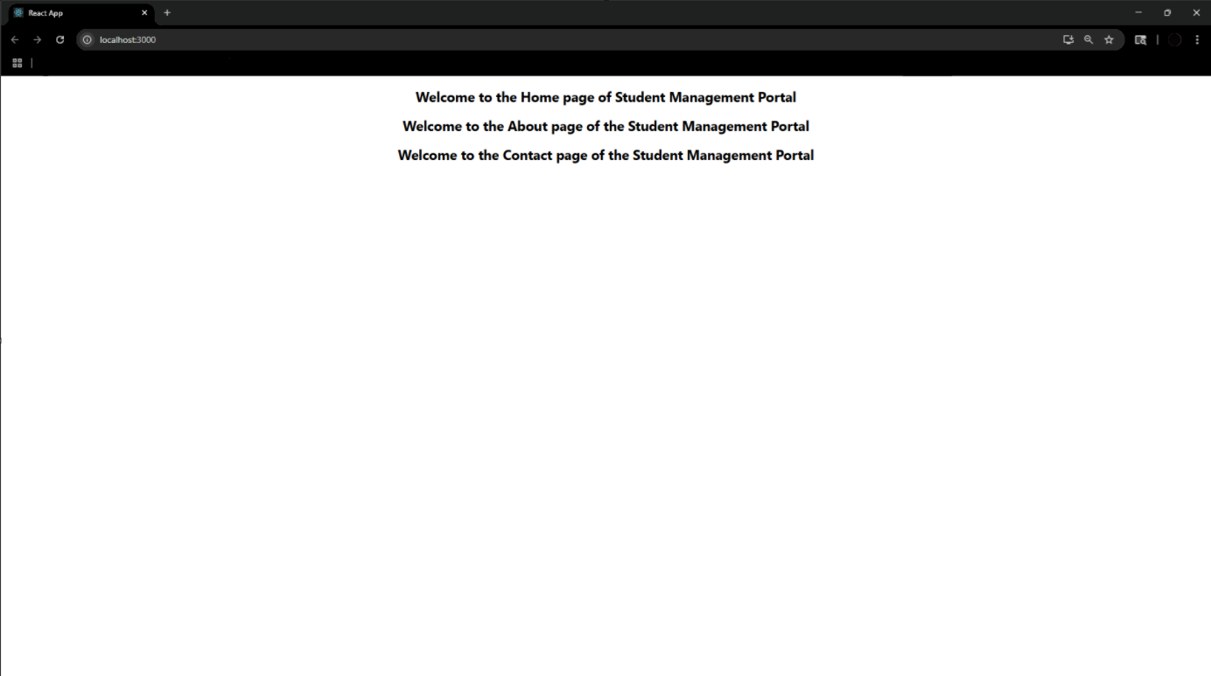

ReactJS-HOL-3
Steps:
1.Create a new project named scorecalculatorapp
npx create-react-app scorecalculatorapp

Program:
CalculateScore.js
import '../Stylesheets/mystyle.css'
const percentToDecimal=(decimal) => {
return (decimal.toFixed(2) + '%');
};
const calcScore = (total, goal) => {
return percentToDecimal(total / goal);
};
export const CalculateScore = ({ Name, School, total, goal }) => (
<div className="formatstyle">
<h1><font color="Brown">Student Details:</font></h1>
<div className="Name">
<b><span>Name: </span></b>
<span>{Name}</span>
</div>
<div className="School">
<b><span>School: </span></b>
<span>{School}</span>
</div>

<div className="Total">
<b><span>Total: </span></b>
<span>{total}</span> Marks
</div>
<div className="Score">
<b>Score: </b>
<span>{calcScore(total, goal)}</span>
</div>
</div>
);

mystyle.css
.Name{
font-weight: 300;
color: blue;
}
.School{
color:crimson
}
.Total{
color:darkmagenta
}
.formatstyle{
text-align: center;
font-size: large;
}
.Score{
color: forestgreen;
}

App.js
import './App.css';
import { CalculateScore } from './Components/CalculateScore';
function App() {
return (
<div>
<CalculateScore
Name={"Steeve"}
School ={"DNV Public School"}
total={284}
goal={3}
/>
</div>
);
}
export default App;

Output:
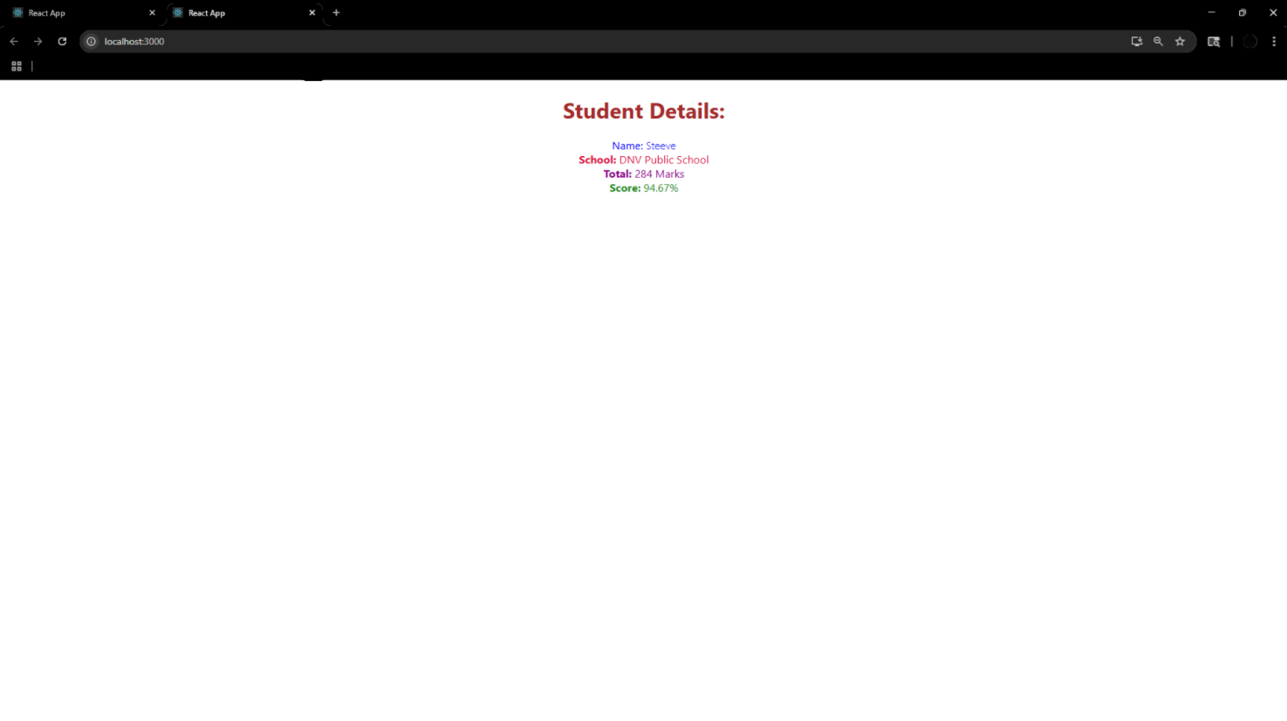

ReactJS-HOL-4
Steps:
1.Create a new react application as blogapp
npx create-react-app blogapp
Program:
Post.js
class Post{
constructor(id,title,body){
this.id=id;
this.title=title;
this.body=body;
}
}
export default Post;

Posts.js
import React from 'react';
import Post from './Post';
class Posts extends React.Component {
constructor(props) {
super(props);
this.state = {
posts: [],
hasError: false
};
}
loadPosts() {
fetch('https://jsonplaceholder.typicode.com/posts')
.then(response => response.json())
.then(data => {
const postList = data.map(item => new Post(item.id, item.title, item.body));
this.setState({ posts: postList });
})
.catch(error => {
this.setState({ hasError: true });
console.error('Error fetching posts:', error);
});
}
componentDidMount() {
this.loadPosts();
}
componentDidCatch(error, info) {
alert('An error occurred while rendering posts.');
console.error(error, info);
}
render() {
if (this.state.hasError) {
return <h2>Something went wrong!</h2>;
}
return (
<div>
<h1>Post List</h1>
{this.state.posts.map(post => (
<div key={post.id} style={{ borderBottom: "1px solid #ccc", marginBottom: "10px" }}>
<h2>{post.title}</h2>
<p>{post.body}</p>
</div>
))}
</div>
);
}
}
export default Posts;

App.js
import React from 'react';
import Posts from './Posts';
function App() {
return (
<div className="App">
<Posts />
</div>
);
}
export default App;

Output:
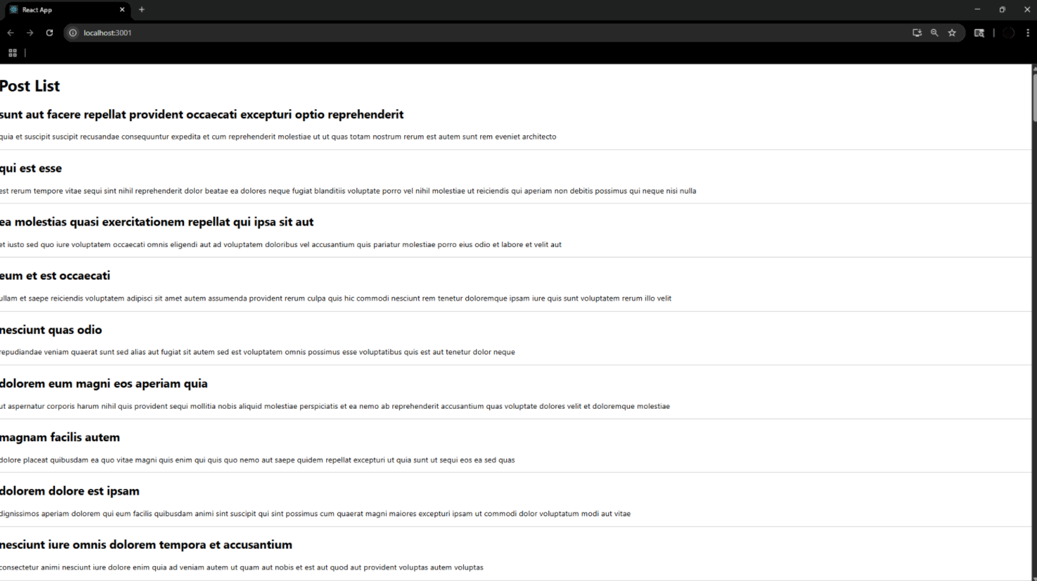

ReactJS-HOL-5
Steps:
1.Install npm
Program:
CohortDetails.module.css
.box {
width: 300px;
display: inline-block;
margin: 10px;
padding: 10px 20px;
border: 1px solid black;
border-radius: 10px;
}
dt {
font-weight: 500;
}

CohortDetails.js
import React from 'react';
import styles from './CohortDetails.module.css';
function CohortDetails(props) {
const { cohort } = props;
const headingStyle = {
color: cohort.currentStatus.toLowerCase() === 'ongoing' ? 'green' : 'blue'
};
return (
<div className={styles.box}>
<h3 style={headingStyle}>
{cohort.cohortCode} - <span>{cohort.technology}</span>
</h3>
<dl>
<dt>Started On</dt>
<dd>{cohort.startDate}</dd>
<dt>Current Status</dt>
<dd>{cohort.currentStatus}</dd>
<dt>Coach</dt>
<dd>{cohort.coachName}</dd>
<dt>Trainer</dt>
<dd>{cohort.trainerName}</dd>
</dl>
</div>
);
}
export default CohortDetails;

App .js
import logo from './logo.svg';
import './App.css';
import { CohortsData} from './Cohort'
import CohortDetails from './CohortDetails';
function App() {
return (
<div>
<h1>Cohorts Details</h1>
{CohortsData.map(cohort => <CohortDetails cohort={cohort}/>)}
</div>
);
}
export default App;
Output:
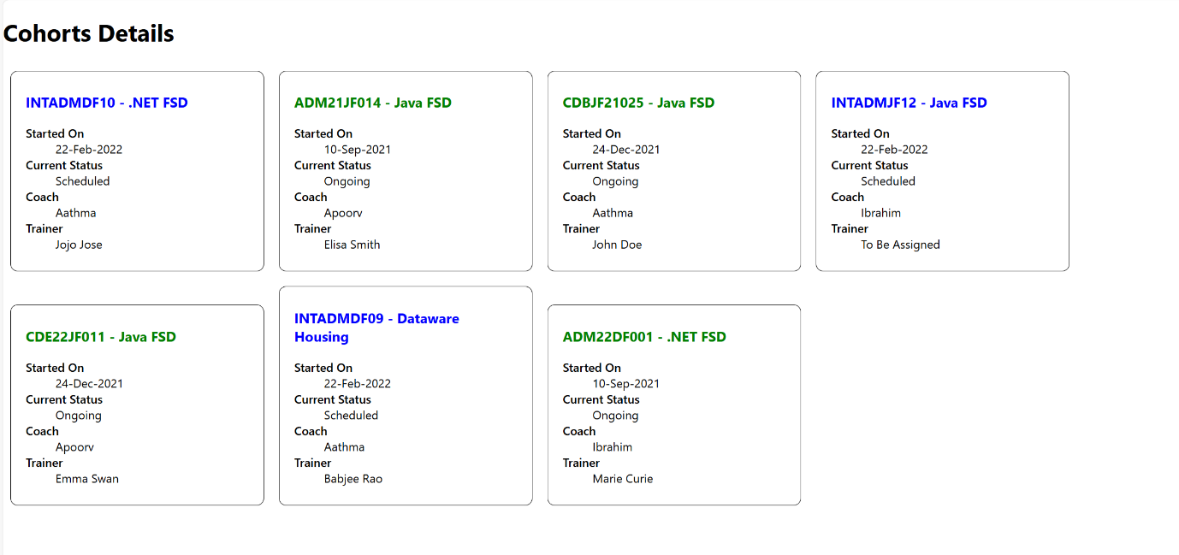

ReactJS-HOL-6
Program:
Trainer.js
class Trainer {
constructor(trainerId, name, email, phone, technology, skills) {
this.trainerId = trainerId;
this.name = name;
this.email = email;
this.phone = phone;
this.technology = technology;
this.skills = skills;
}
}
export default Trainer;

trainersMock.js
import Trainer from "./Trainer";
const trainersMock = [
new Trainer(
't-syed8',
'Syed Khaleelullah',
'khaleelullah@cognizant.com',
'97676516962',
'.NET',
['C#', 'SQL Server', 'React', '.NET Core']
),
new Trainer(
't-jojo',
'Jojo Jose',
'jojo@cognizant.com',
'9897199231',
'Java',
['Java', 'JSP', 'Angular', 'Spring']
),
new Trainer(
't-elisa',
'Elisa Jones',
'elisa@cognizant.com',
'9871212235',
'Python',
['Python', 'Django', 'Angular']
)
];
export default trainersMock;

TrainerList.js
import React from 'react';
import { Link } from 'react-router-dom';
function TrainerList({ trainers }) {
return (
<div>
<h2>Trainer List</h2>
<ul>
{trainers.map(trainer => (
<li key={trainer.trainerId}>
<Link to={`/trainer/${trainer.trainerId}`}>{trainer.name}</Link>
</li>
))}
</ul>
</div>
);
}
export default TrainerList;

TrainerDetails.js
import React from 'react';
import { useParams } from 'react-router-dom';
import trainersMock from './trainersMock';
function TrainerDetails() {
const { id } = useParams();
const trainer = trainersMock.find(t => t.trainerId === id);
if (!trainer) return <h2>Trainer not found!</h2>;
return (
<div>
<h2>{trainer.name}</h2>
<p><strong>Email:</strong> {trainer.email}</p>
<p><strong>Phone:</strong> {trainer.phone}</p>
<p><strong>Technology:</strong> {trainer.technology}</p>
<p><strong>Skills:</strong> {trainer.skills.join(', ')}</p>
</div>
);
}
export default TrainerDetails;

Home.js
import React from 'react';
function Home() {
return (
<div>
<h1>Welcome to Cognizant Academy Trainer Portal</h1>
<p>Use the navigation menu to explore our trainers.</p>
</div>
);
}
export default Home;

App.js
import React from 'react';
import { BrowserRouter, Routes, Route, Link } from 'react-router-dom';
import Home from './Home';
import TrainerList from './TrainerList';
import TrainerDetails from './TrainerDetails';
import trainersMock from './trainersMock';
function App() {
return (
<BrowserRouter>
<div>
<nav>
<Link to="/">Home</Link> | <Link to="/trainers">Trainers</Link>
</nav>
<Routes>
<Route path="/" element={<Home />} />
<Route path="/trainers" element={<TrainerList trainers={trainersMock} />} />
<Route path="/trainer/:id" element={<TrainerDetails />} />
</Routes>
</div>
</BrowserRouter>
);
}

export default App;

Output:

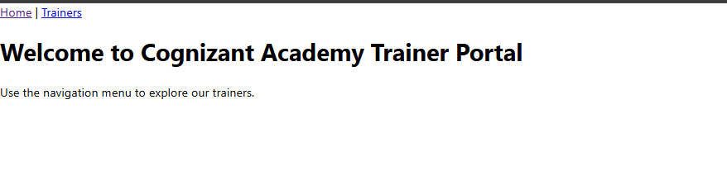
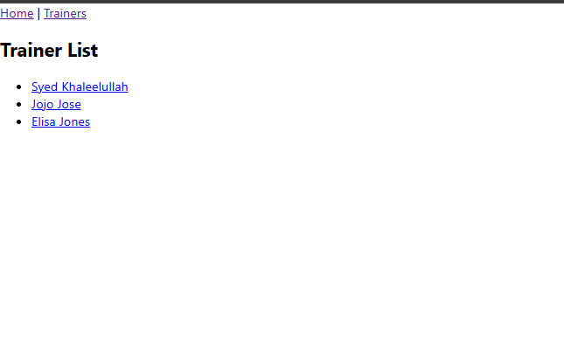
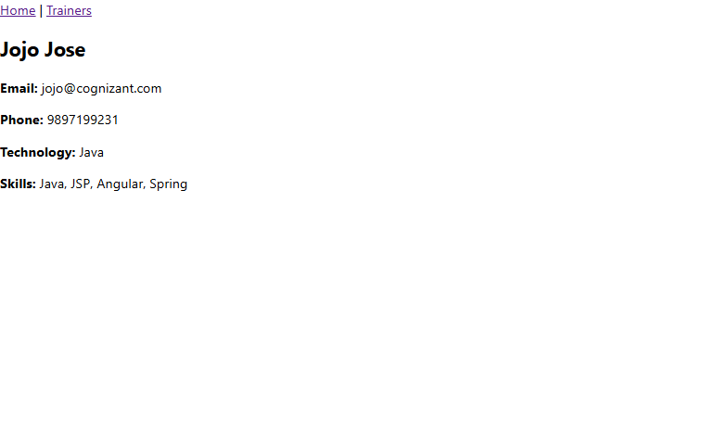

ReactJS-HOL-7
Program:
Cart.js
import React from 'react';
class Cart extends React.Component {
render() {
return (
<div>
<table border="1" cellPadding="10">
<thead>
<tr>
<th>Item Name</th>
<th>Price (₹)</th>
</tr>
</thead>
<tbody>
{this.props.item.map((item, index) => {
return (
<tr key={index}>
<td>{item.itemname}</td>
<td>{item.price}</td>
</tr>
);
})}
</tbody>
</table>
</div>
);
}
}
export default Cart;

OnlineShopping.js
import React from 'react';
import Cart from './Cart';
export class OnlineShopping extends React.Component {
render() {
const CartInfo = [
{ itemname: "Laptop", price: 80000 },
{ itemname: "TV", price: 120000 },
{ itemname: "Washing Machine", price: 50000 },
{ itemname: "Mobile", price: 30000 },
{ itemname: "Fridge", price: 70000 }
];

return (
<div className="mydiv">
<h1>🛒 Items Ordered :</h1>
<Cart item={CartInfo} />
</div>
);
}
}
export default OnlineShopping;

index.js
import React from 'react';
import ReactDOM from 'react-dom/client';
import './index.css';
import OnlineShopping from './OnlineShopping';
const root = ReactDOM.createRoot(document.getElementById('root'));
root.render(<OnlineShopping />);

Output:
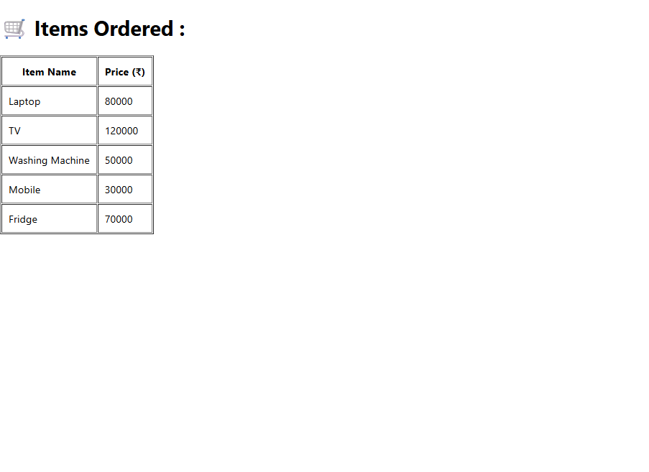

ReactJS-HOL-8
Program:
CountPeople.js
import React, { Component } from 'react';
class CountPeople extends Component {
constructor(props) {
super(props);
this.state = {
entryCount: 0,
exitCount: 0
};
}
UpdateEntry = () => {
this.setState((prevState) => ({
entryCount: prevState.entryCount + 1
})
);
}
UpdateExit = () => {
this.setState((prevState) => ({
exitCount: prevState.exitCount + 1
})
);
}
render() {
return (
<div style={{ textAlign: 'center', marginTop: '50px' }}>
<h2>Mall Entry Counter</h2>
<p>Number of people entered: {this.state.entryCount}</p>
<p>Number of people exited: {this.state.exitCount}</p>
<button onClick={this.UpdateEntry} style={{ marginRight: '10px' }}>Login</button>
<button onClick={this.UpdateExit}>Exit</button>
</div>
);
}
}
export default CountPeople;
App.js
import React from 'react';
import CountPeople from './CountPeople';
function App() {
return (
<div>
<CountPeople />
</div>
);
}
export default App;

Output:
